**Stats 201 HW7**

8.4

a. R2 = 0.7632, from the plot it appears to be a good fit. The regression function is Ŷ = 207.349608 - 2.964323*X + 0.014840*X2

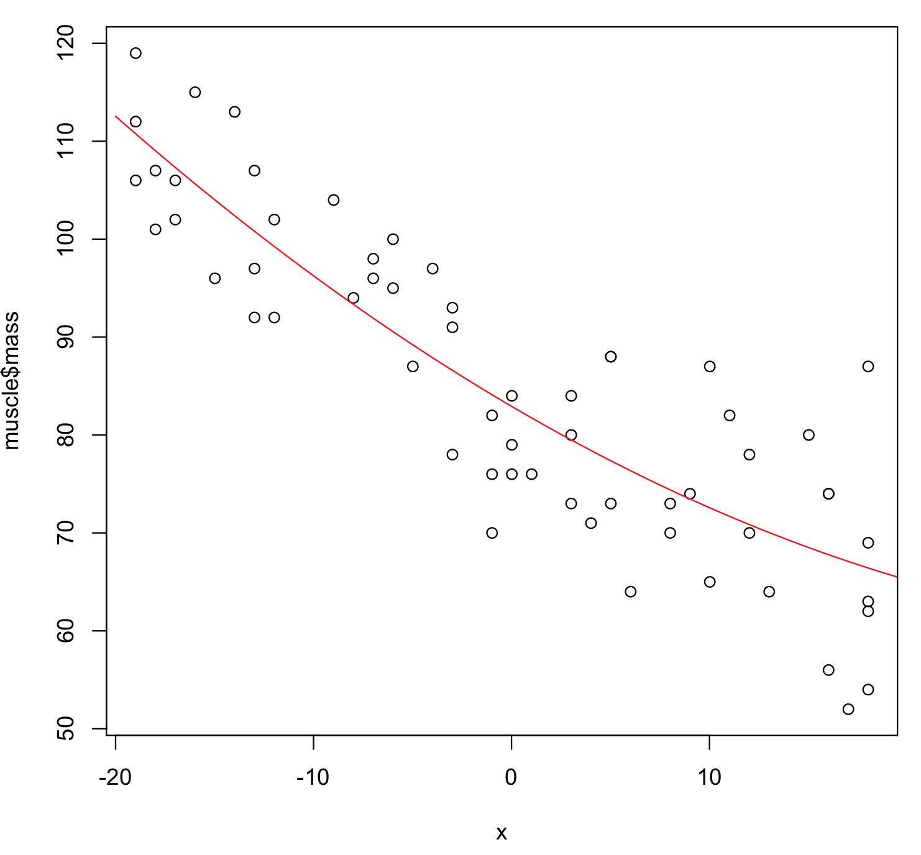

b. H0: β1 = β2 = 0. Ha: At least one of β1 and β2 is not zero. Decision rule: if p-value < 0.05, reject H0. Conclusion: p-value = 2.2e-16 < 0.05 (from summary), reject H0, which means there is a regression relation.

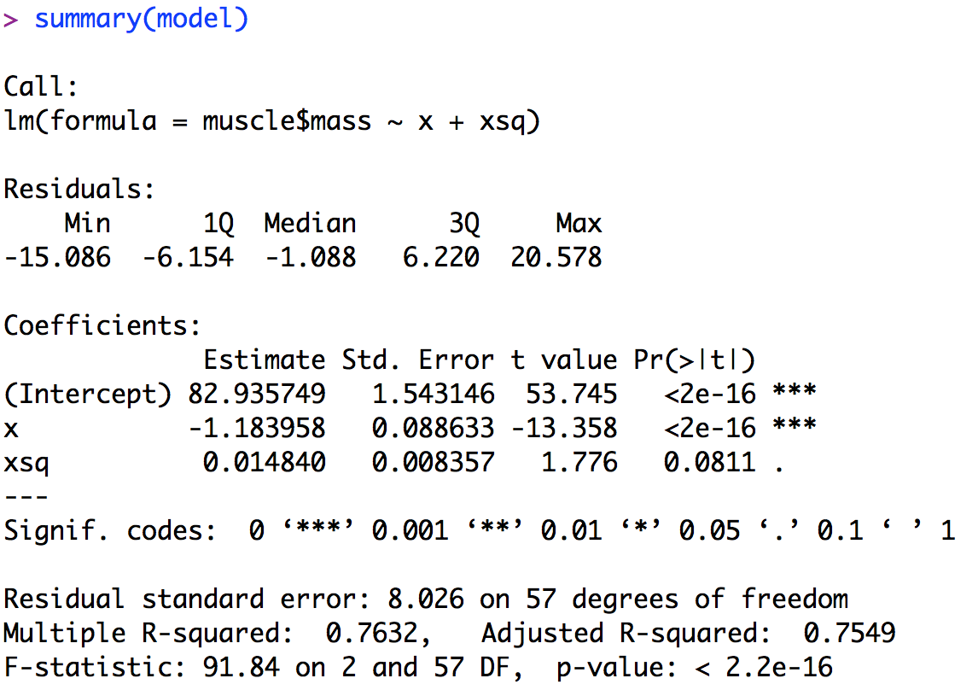

e. H0: β2 = 0. Ha: β2 ≠ 0. Decision rule: if p-value < 0.05, reject H0. Conclusion: p-value = 0.0811 < 0.05 (from summary), do not reject H0, which means that we can drop the quadratic term from the model.

g. cor(X, X2) = 0.996, cor(x, x2) = -0.038. It is useful here because the correlation is reduced after centering X.

8.17

If β2 = 0, X2 will have no effect in model (8.49), but still have some effects in model (8.49) because of the interaction term: when β2 = 0 the intercept of the two types of firms are the same, but their slopes are different.

8.34

a. Ŷ = β0 +β1X1 + β2X2 + β3X3

b. Commercial: Ŷ = (β0+β2) + β1X1

Mutual savings: Ŷ = (β0+β3) + β1X1

Savings and loan: Ŷ = (β0-β2-β3)+ β1X1

c. (1) β2: the amount added to get the intercept of type Commerical from the average intercept of the three types (2) β3: the amount added to get the intercept of type Mutual savings from the average intercept of the three types (3) –β2-β3: the amount added to get the intercept of type Savings and loan from the average intercept of the three types